INF305
Engaging with the
Information Professions
Revised 2017

School of Information Studies
Bachelor of Information Studies

This Handbook is reviewed annually in January. Please re-visit the INF305 site within the School’s Professional Experience website to check the Handbook for any changes throughout your enrolment in the course.

https://arts-ed.csu.edu.au/sis/professional-experience/inf-305

TABLE OF CONTENTS
Page
Introduction 2
Overview 2

Objectives 2

Assessment Requirements 2

Why Professional Activities? 3

Professional Activities 5
Requirements 5
Documentary Evidence 5
Guidelines for Choosing a Range of Professional Activities 5
Suggested Activities 5
Unsuitable Activities 6
What have previous students thought of this subject? 7
Contacts 9
Guidelines for Completion of the activity reports 11
Example of Description and Evaluation of Activity 12
How I Plan To Use This learning 13
Summary of Professional Activities 13
Record of Participation in Professional Activities 15

ThinkSpace 16
Part 1: Instructions for creating your site in ThinkSpace 16
Choosing/Changing Your Theme 17
Privacy Settings 17
Part 2: Tailoring Your Home Page 18
Part 3: How To Add A Page 19

Frequently Asked Questions about INF305 20

INTRODUCTION
INF305 – Engaging with the Information Professions, is a compulsory subject for the Bachelor of Information Studies, and is worth 8 credit points. Please READ ALL of this Handbook now, so that you know what you need to be doing to have this subject ready for enrolment and completion by the end of your degree.

The aim of this subject is to encourage our students to commit to continuing professional development and becoming a reflective practitioner. INF305 is one of the three subjects that make up the Workplace Learning Strand within the BIS program. The other subjects in the Professional Experience strand are:

INF214 – Professional Study Visit, and
INF208 - Professional Placement.

You should not enrol in INF305 until you are just about to complete the course. That is primarily because one of the two assignments includes your reflective report on 30 hours of accumulated professional development activities that you are allowed to count from the commencement of your course.

Overview
Students are required to attend and report on a minimum of 30 hours of professional activities (such as conference sessions, seminars, workshops) of value to the development of library and information services professionals.

Objectives
Upon successful completion of this subject, students will be able to:

- reflect critically on learning associated with a range of professional development activities undertaken at local, regional, state, national or international level
- demonstrate understanding of the value of continuing professional development as a component of professional practice
- demonstrate their ability to review, evaluate and analyse professional development activities and apply this to their lifelong learning practices
- apply critical thinking and judgement to demonstrate understanding of key issues in their chosen areas of professional interest, and
- understand the value of reflection in planning professional and career development.

Assessment requirements
There are two assessment tasks in this subject. The first assignment comprises of:

- a critical analysis of two information professionals' e-portfolios (provided by the subject coordinator) based on a set of criteria provided and content in the subject modules; and
- creation of a ThinkSpace site (or re-configuration of an existing one to include a space for your INF305 second assignment material) plus a basic LinkedIn profile.
The second assessment task is the completion of the student’s professional ThinkSpace website which will include:

- the reflective writing component about the 30 hours of professional development activities (and accompanying evidence of attendance/participation for each)
- creating a professional, up-to-date curriculum vitae.

Why Professional Activities?
One of the aims of the degree you are studying is to produce graduates who will be proactive in ensuring their own professional development, and who are reflective practitioners. Continuing Professional Development (CPD) is actually compulsory in some professions, but our own professional body, the Australian Library and Information Association (ALIA), believes that individuals must take responsibility for their own CPD.

This subject aims to encourage each student to begin the CPD habit. The following formal statement places this in context.

Excerpt from the ALIA Statement on Professional Development for library and information professionals (Amended 2009)
Professional development demonstrates the individual practitioner's personal commitment of time and effort to ensure excellence in performance throughout his or her career. The dynamic and changing library and information environment demands that library and information professionals maintain and continue to develop their knowledge and skills so that they can anticipate and serve the information needs of society and their individual clients.
Professional development includes many learning experiences - within and outside the workplace - which aim to increase knowledge, develop library and information skills and attributes and broaden the range of vocational competencies. Learning activities may relate to an extension of general or specialist areas of library and information management education, development of the body of knowledge underlying professional practice, development of the reflective practitioner, development of research expertise, or studies from another discipline which lead to personal and professional development.
The Australian Library and Information Association expects that learning opportunities will be made available in a number of different formats and offered in a variety of different delivery modes. Learning experiences include but are not limited to formal education at advanced (post-first qualification) level, formal training courses informal learning activities, mentoring, workplace learning, seminars, presentations, research and service activities.
The Association's commitment to its members achieving their career goals is demonstrated by:
- providing mechanisms which enable members to plan and undertake learning and other development activities;
- offering a mentoring program to assist members in their ongoing professional development;
- organising partnerships with other professional and training organisations to make available learning activities and opportunities in library and information management and other disciplinary studies;
- formally recognising members who participate in ALIA's professional development certification scheme;
- facilitating forums where knowledge can be created, shared and disseminated to enable members to better understand the dynamic environment in which they, as library and information professionals, and their clients operate.
Source: https://www.alia.org.au/about-alia/policies-standards-and-guidelines/professional-development-library-and-information-professionals

PROFESSIONAL ACTIVITIES
Requirements
Students are required to complete a minimum of 30 hours of professional activities which are relevant to the development of library and information services professionals.

As you attend each activity, take notes so that you can write reflectively about each activity attended. Also make sure you gather documentary evidence of your participation or attendance at the activities.

Your Subject Outline provides direction about how many words you should write about the activities you participate in.

Further on in this Handbook you will find some guidance about the activities which may be attended to meet the requirements of the subject. The Handbook also gives an outline of how to write reflectively about the professional activities attended.

Documentary Evidence
Charles Sturt University (CSU) requires someone to verify that you have attended or participated in each activity. This can be through the signature of one of the presenters or organisers of the activity, or of your supervisor or manager if you are currently working. Use the record of participation form in this Handbook for this if you wish. Proof of attendance can also be a participants or delegates list produced for the activity, or a certificate of attendance, completion or participation issued by the organiser of the activity, or even the receipt for fees paid to attend. Other examples of appropriate evidence are given later in this Handbook.

Guidelines for Choosing a Range of Professional Activities
At the beginning of each year of study, make sure you plan your activities for that year. Check where you are up to in numbers of hours, and plan accordingly.

Don’t leave this until your last year of study and certainly not the session you enrol in the subject!

While 30 hours is not a large number of professional development activities to accumulate, it may be difficult to achieve this if you leave it until the last minute.

Ideally you should choose professional activities which will help improve your performance at work or in your studies, allow for growth in your professional life, or help you progress towards achieving specific career goals.

Suggested Activities
The following list suggests the kinds of activities that will meet the requirements of the subject without you having to contact the School for confirmation. It is not exhaustive, but is a guide to your choices of activity.

Seminars, Workshops, Short courses, Conferences
These could range from a couple of hours, a half day or even up to a full week, and be run by your own organisation, a professional body, a tertiary institution, a commercial training body, etc.

Meetings of Professional Bodies (e.g. ALIA, ASLA, SLAV, SLAQ, ASA, RMAA)
These will generally be meetings at which there is a guest speaker, or discussion of professional issues that involve the participants. This may also include being a committee member, member of an event organising committee, etc. but you must be able to show you’re an active participant in these. You can include up to 1 to 4 hours for these.

In-Service Training Programs
These are usually run in, or by, your own organisation, and aim to assist learners to be more effective in their current position or provide them with skills and knowledge as developmental preparation for future positions. They could be focussed on such topics as new Library Management Systems, Working with Difficult Clients, Cross-cultural Awareness or many others.

Participation in a recognisable working party, professional group or project
These might be where you are a member of a recognisable section of an organisation or where you play a significant role in a team working on a project. For example, you might have been part of the local studies working group that participated in the local studies audit of the NSW Public Libraries where you made a significant contribution. All of these might be included if they are not part of your normal work duties. Please check with the subject coordinator if unsure.

Unsuitable Activities
Some activities are not deemed appropriate for inclusion in your 30 hours for the purpose of professional development as an information professional – even though they are important skills and knowledge to have in the workplace. For example, the following types of training – regardless of who offers them – would not generally qualify:

- Fire warden training or other Occupational Health & Safety or Workplace Health and Safety training activities
- Common software programs such as Word or PowerPoint training
- General staff or similar meetings (even if professional issues are discussed)

Still uncertain about what might, or might not, be suitable?

If you are in doubt, contact the Subject Coordinator. It is best you do this via email, providing details about the type of activity you are asking about. This might include information such as – the name of the training or event, the name of the organisation or person conducting it, the relevance of the training or event to your professional development or career growth and possibly a web link to further information which will assist the subject coordinator to make a decision on its suitability. To check who the subject coordinator is in any session, contact the school via email at
SIS-Office@csu.edu.au or phone +61 2 6933 2853.

What have previous students thought of this subject?

As a library student not working in libraries I was a bit daunted about the prospect of attending conferences and workshops, etc. Everyone would know someone else and I would be left to wander around alone … however it didn't end up like that. I met some great people, had interesting conversations over lunch and shared experiences. I took away a lot of new ideas which will help me in future information work. I believe it is so important to participate in these activities because they really do give you an insight into the changing information environment.

***************************************************************************

When first hearing that I had to do 30 hrs, my initial reaction was disbelief at such an unrealistic number. It would be far too difficult to get that time in a couple of years and bloody expensive. Well, three and a half years and 84 hrs later, the difficulty was - what I had documentation for. So I have learned to try and keep more documentation.

As a learner I think I actually learn better through short professional development subjects and while I enjoy the rigor of academic study, its nice when there is no formal assessment and the decision as to whether it is beneficial is largely self-assessed. I have discovered that ALIA’s various groups are quite welcoming although still a little cliquey – and that it is often those that have been in the profession for many years that make the most effort to welcome.

As I have become a professional development junkie, I will continue to attend courses, conferences, seminars etc. I have started attending conferences about things other than libraries and transferring their ideas into the library environment. If I hadn’t attended a Leadership workshop, I would not have met my current boss and obtained my current job...

There are lots of things that you can do for little or no cost such as writing a paper, going to an author visit at your local library. ALIA offers lots of low cost things, I presented at a workshop for library technicians on reference work, cost was $5 for members $10 for non-members, just have a look on the ALIA web page, cost to me as a presenter $0 but I can honestly say I learned a lot from both the experience of presenting and from what the attendees brought to the discussion.

There are lots of things that aren't necessarily presented as 'library' that may be offered through TAFE or your current workplace in customer service or report writing or running meetings, etc. Basically you have to ask yourself 'How will this improve me as a Library Professional? What have I learned and how have I grown?' And remember that you may be able to claim some of this on your tax return so speak to your accountant.

***************************************************************************
I enjoyed this unit very much and I wish I had thought of doing something like this independently a long time ago. It would have aided me in my understanding of where I was going professionally and taught me to critically analyse my activities.

***************************************************************************
I enjoyed this subject, and found it very useful in developing a career plan and thinking about my past (and future) achievements. Not all of this reflection was done within the portfolio, but the learning in the subject led to broader and deeper reflection on my career goals. It was also a valuable experience to consider my place within the library profession.

Contacts

The following list of contacts should get you started. Be aware of the need to be looking regularly for activities that will enhance your knowledge and fulfil the requirements of this subject. Look at websites, read newsletters. SIS staff, including the INF305 subject coordinator, also post events on the BIS online course forum.

Australian Library and Information Association

Incite (monthly news magazine)

ALIA Website (http://www.alia.org.au/events)

ALIA has a national office in Canberra, and a branch in each state and territory. There are also regional groups (eg Riverina, Hunter, North Queensland), sectional groups (eg reference and information services, public libraries, acquisitions), and special interest groups (eg distance education, rural and isolated libraries). Many of these offer their own activities, publicising them in their own newsletters, on the ALIA website, and in Incite. ALIA’s Biennial Conference or specialised conferences, are a great opportunity for professional development and networking, and generally could fulfil the requirements for the full 30 hours of this subject.

Another ALIA service where you can discover activities are the e-lists provided for students at:
https://www.alia.org.au/elists/aliastudents

The following websites are also helpful sources of information about professional development and growth opportunities:

From, the ALIA Schools group:
https://www.alia.org.au/groups/alia-schools

The Australian Society of Archivists:
http://www.archivists.org.au/learning-publications/professional-development-courses

The Records and Information Management Professionals Australasia:
http://rimpa.com.au/professional-development/

ARK Group Australia provide professional development information about a range of areas including knowledge management, content management, information management and more.
http://www.arkgroupaustralia.com.au/events/

ALIA may be your main source of information for contacts, but consider and be aware of:
In-house newsletters in your own workplace
Other libraries and information agencies (e.g. National Library, State Libraries, etc)
Flyers from professional and commercial training bodies
Library systems suppliers and trainers
Newspapers

And other related professional bodies, e.g.
Australian Computer Society
Institute for Information Management
Literature, publishing associations and conferences
Guidelines for Completion of the activity reports

We require that you write up your report within the word guidelines specified in the subject outline. That is, your descriptions and reflections on each activity should be approximately 100-150 words for activities that range from 1-6 hours in length, 200-300 words for those that range from 7-12 hours in length or 400-600 words for those that are 13 hours and over.

Generally we prefer that you do more than one activity, even if the hours within them add up to 30. For example, attending a major conference may fulfil 30 hours but we would rather you attend at least 2 or more.

Description of Activity
Describe the activity in terms of its

- content or subject area (eg document delivery)
- type (eg seminar)
- length (eg 7 hours)
- level (eg for acquisition librarians)
- organisers (eg ALIA NSW Acquisitions Section)
- presenters (eg John Kennedy, CSU and Irene Owens, University of Texas)
- format (eg a one hour lecture, followed by 3x2 hour workshop sessions in small groups)

If possible, attach a notice or link to the program for each activity you attend. If there are choices of sessions to attend, as with a conference, then note which sessions you attend, and describe and evaluate each one.

Evaluation of Activity
- outline briefly the objectives of the activity,
- and the reason you have attended
- give an indication of the relationship of the activity to your work or studies
- explain what the activity achieved for you in terms of learning outcomes
- comment on how you plan to use the learning gained

Portfolios which fail to provide sufficient reflection on, or evaluation of, the activities may be returned to the student for re-submission.

Example of Description and Evaluation of Activity
ALIA Workshop entitled “The Reference Process”.

Presenter: Grace Kendall
Information Services Manager
State Library of New South Wales

Date: 23 April 2011

Time: 9.00am – 5.00pm

Duration: 8 hours

Description of Activity
Held at CSU Library. Morning sessions concentrated on the reference process, communication skills, and information-seeking behaviours; lectures and small group workshops. Afternoon sessions were small group practical exercises including role-plays and actual searches for information. Evaluation session at conclusion.

Evaluation of Activity
[Include, at least, the objectives and content of the activity, along with its relationship to your work or studies, and the specific learning outcomes for you.]

Objectives
- to introduce or reconfirm those basic skills involved in the face-to-face delivery of reference and information services
- to raise awareness of the essential skills required of reference librarians
- to learn skills which can be used and practiced after the workshop

Reason for Attending
Our Library Director encourages staff to attend any activities organised by ALIA. This activity was attended by two of our less experienced information services staff to help us develop our reference work skills.

Relationship of the Workshop to My Work or Studies
I have been rostered on our information desk once a week this year, but have not yet received the full training our library usually gives. It is an ideal opportunity for me to learn some basic and more advanced skills in reference, an area I am expected to be part of more in future.

Learning Outcomes
Learned some basic communications skills involved in the face-to-face delivery of reference and information services.

I learned the importance of communication in the reference process; when the client defines the problem, when the librarian gathers information to clarify the problem, and as the librarian implements the search plan and tests possible solutions, the processes of communication are most important.

I learned that the key components and skills required are those of listening and communicating.

How I Plan to Use the Learning
I will be required to report back to a staff meeting, and also be expected to apply what I have learned when on the Information Desk in future.

Through this experience, I aim to:

- improve my library’s performance eg increasing the number of requests that are successfully fulfilled, and improving the turn-around time in reference requests;
- improve performance from the customer’s perspective by considering how customers themselves evaluate the quality of service they receive;
- be reliable, by doing what we say we are going to do, and doing it right the first time, every time;
- be responsive and empathetic when dealing with customers;
- make service encounters a pleasurable experience for the customer.

We also received a handout that gives some exercises that will enable us to consider our interpersonal and communication skills, and requires us to consider how people might respond to us. I will use those to become more self-aware, as the first step to improving the relationship between our library and its customers.
Summary of Professional Activities
Use this page to list in summary form the activities you have undertaken, when they occurred, and keep track of the number of hours you have achieved.

Activity | Date | Duration | Hours  recorded | Evidence attached?  Please Tick

Record of Participation in Professional Activities

Activity

Date

Time Duration

Description of Activity

Evaluation of Activity
[Include, at least, the objectives and content of the activity, along with its relationship to your work or studies, and the specific learning outcomes for you]

----------------------------------------**********************----------------------------------------
Evidence of attendance or participation

I certify that …………………………………. has attended/participated in the above activity.

Signed ……………………………

Name ……………………………………. Position …………………………………………

THINKSPACE GUIDE

This guide is divided into three specific parts about how to create your ThinkSpace site:

Part 1: Instructions for creating your own site in ThinkSpace
Part 2: Tailoring your home page
Part 3: Adding a page to your site

Note: For other instructions or help for things you may not understand, visit the User Guide as it will provide very detailed information.

Part 1: Instructions for creating your site in ThinkSpace

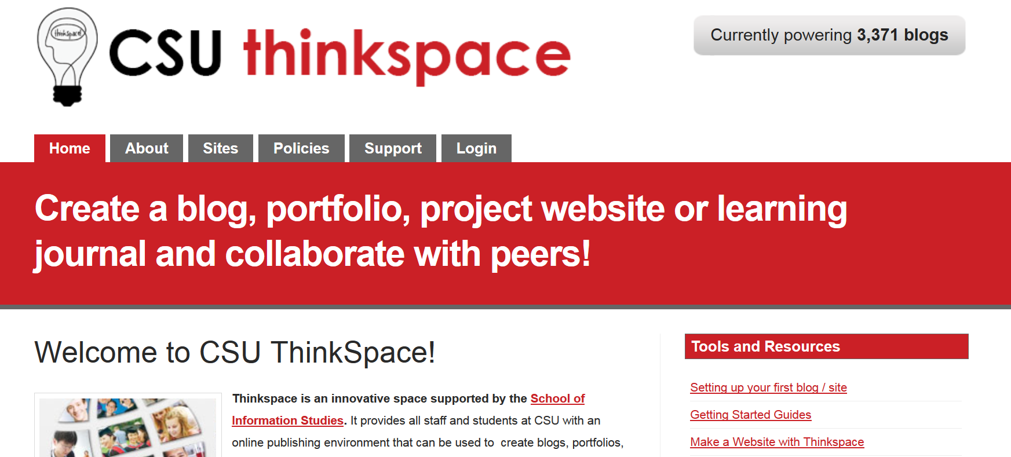

1. Click on the ThinkSpace page at: http://thinkspace.csu.edu.au/

2. Click on Setting up your first blog / site

3. Follow the instructions on the screen.

4. For the purposes of the task in this subject, call it by the Subject Code and then your initial and surname (eg. inf305sjones). Take note of the required length of your site name (no nicknames!) and other criteria so that it is easier from our end to mark etc. please.

4. Make a note of the URL that is then created for your site that appears in the box under the heading Your site will be located at this URL
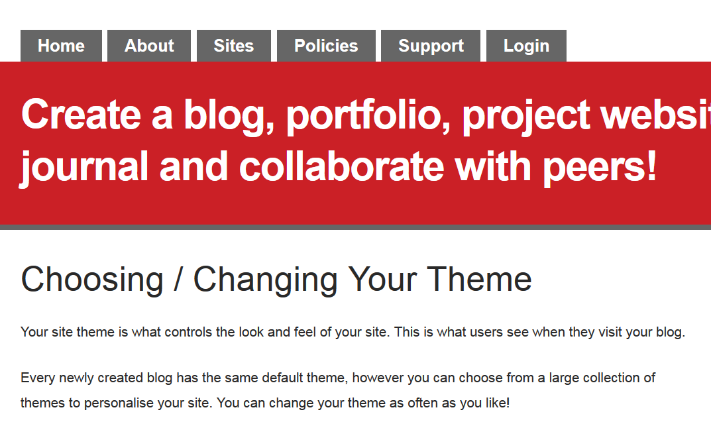

5. Click on Choosing / Changing Your Theme and pick a theme that you like. Keep in mind that this should be a reasonably sensible one since this is for an assessment task!
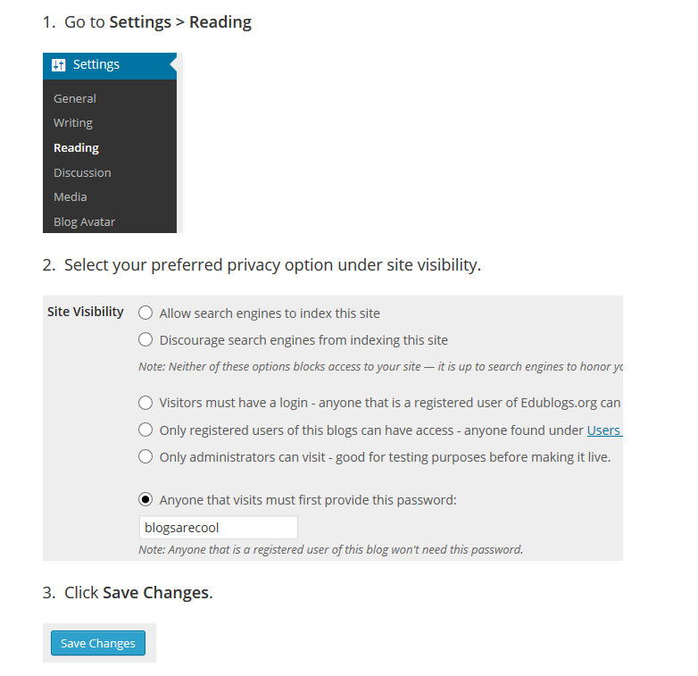

6. In the Site Settings section titled Privacy Settings it is ABSOLUTELY ESSENTIAL that you choose the option Anyone that visits must first provide this password. This is critical because you are creating this site for an assessment task and therefore should not be shared with others to prevent collusion, plagiarism or anything else against the Student’s Code of Conduct. You will be given instructions by your subject coordinator about how you are to provide access to – i.e. themselves and the markers in that subject.

7. You will then be asked to type in a password that is specific to your site.

8. Click on Save Changes

9. Ensure that the password is made available to the subject coordinator when required.

Part 2: Tailoring your Home Page

1. Make sure you are on your home page of your site

2. Link to Choosing / Changing Your Theme

3. Choose a theme which matches your style.

Part 3: How to add a page

1. To add pages to your site for various sections, you just need to go to the Publish New Page page at help.edublogs.org/writing-pages/ and click on Publishing a new page. The number of pages you have on a site will vary – ie. you might have been given specific headings to make pages for or it might be up to you.

2. Go to Pages>Add New

3. Once you have finished choosing your options and added your content, click on Publish page.

Frequently Asked Questions about INF305

Why do I need to do professional development?
One of the aims of the degree you are studying is to produce graduates who will be proactive in ensuring their own professional development, and who are reflective practitioners. Continuing Professional Development (CPD) is actually compulsory in some professions. The leading professional body for librarians in Australia, the Australian Library and Information Association (ALIA), believes that individuals must take responsibility for their own CPD. Many professional associations leave off the 'C' and just list it as Professional Development. Some associations that use CPD also list the 'C' as compulsory.

When do I become an information professional?
Information professionals work with many forms of information in different forms and different settings. For example, there are many forms of information appearing in items such as books, magazines, audio and video recordings, images and other graphics as well as many digital resources. The field of work for the information professional has expanded greatly in recent years and can encompass many roles such as librarians, knowledge managers, information architects, records managers, archivists, data managers and many more. As such there are different responsibilities in each however information and people or systems play a pivotal role. There are typically professional associations relating to many of those positions outlined above. As mentioned, ALIA is the peak body which covers those working in all kinds of libraries and other closely related environments. There are, however, other specialised associations which you may also become familiar with if you choose to specialise in a particular area as an information professional. These associations usually provide a range of services and resources for their members, often including training and professional development activities. You should make yourself familiar with the Association most likely of relevance to you. Information professionals attend regular professional development activities and are an active participant in the information industry.

Do I need to be a member of a professional association to be an information professional? You do not need to join a professional association for this subject. However this is the perfect time to start looking at professional associations and seeing which one may be the most appropriate for you to join. Joining a professional association may actually save you money. By joining a professional association you usually get discounts on the professional development activities that are run by that association. In cases such as a major conference like the ALIA Biennial Conference you will save most of the membership fee for that year by joining ALIA. All associations want members and this is one way they attract members. The peak body ALIA includes a group called Students and New Graduates which offer many opportunities for networking over social and professional activities. You can read more about what they do here.

Why do I need to do 30 hours of professional development? Students are required to attend and report on a minimum of 30 hours of professional activities (such as conference sessions, seminars, workshops) of value to the development of library and information services professionals. We ask that you reflect in writing on the learning that you have undertaken through the course on selected assignments, as well as study visits and placements, and the required hours of professional activities.

The 30 hours is seen as a base number of hours to show that you are serious about your own professional development. Once you start looking at exactly the amount of hours you may need to do over the next couple of months you will find that you the events, conferences and others training sessions you attend will be well in excess of 30 hours. You only need to report on 30 hours.

What proof do I need to submit that I actually attended a specific activity?
Charles Sturt University (CSU) requires someone to verify that you have attended or participated in each activity. This can be through the signature of one of the presenters or organisers of the activity, or of your supervisor or manager. Proof of attendance can also be a participants or delegates list produced for the activity, or a certificate of attendance, completion or participation issued by the organiser of the activity, or even the receipt for fees paid to attend. For webinars you can do a screen shot mid-way through.

How will do the work in this subject help me professionally (ie. outside of being a student having this assessed)?
The Australian Library and Information Association (ALIA), has a professional development scheme, whereby members can revalidate their associate (i.e., professional) member status by compiling evidence that they are keeping abreast of professional issues and updating their skills and knowledge on a continuing basis. ALIA's Professional Development scheme guidelines recommend that members build a portfolio of their professional development (PD) activities. If anyone in the class is a member of that scheme, they can use the activities and reflections from this subject to feed into that scheme.

